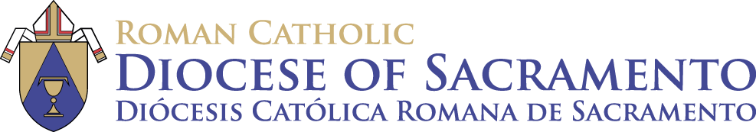

Diocese of Sacramento RCIA Committee Presents:

**Journey Toward Mission 2020**

**Retreat Journal**

**Section 1 – Reflection on the Creed - Points to Ponder**

1. When Jesus asked his disciples, “who do people say that I am?”, there were many responses. Then Jesus asked, “Who do YOU say that I am?” What is your answer to that question? Type response below:

1. What reality is the Profession of Faith based on?

Type response below:

1. There are many points professed in the Creed… which point resonates with you the most?

Type response below:

**Section 2 – Ephphetha Rite Reflection**

Type response below:

**Section 3 – Baptism Reflection**

Type response below:

**Section 4 - Presentation of the Our Father**

Type response below:

**Section 5 – Confirmation – Points to Ponder**

1. Using a situation you have recently experienced, how could you have used any (or all) of the Seven Gifts to respond to the situation in order to build the Kingdom of God by helping those involved to meet the Risen Lord through you?

Type response below:

1. Write a sentence or two about how you think God might be using you now, or how he might use you in the future to build His Kingdom.

Type response below:

1. Have you noticed any ways in which God might have used you to bring Him to others in your life so far? If so, write a sentence or two about an experience you can think of where you have responded to His call.

Type response below:

**Section 6 – Optional Activity**

Type your letter to God here:

**Closing Comments**

Type your closing comments/reactions to this Virtual Retreat here: