Insert Parish Name – Diocese of Sacramento
Infectious Disease Preparedness and Response Plan

Definitions (from Centers of Disease Control and Prevention or CDC)
- Epidemic – an increase, often sudden, in the number of cases of a disease from what is expected in a population in that area
- Pandemic – an epidemic that has spread across several countries or continents, usually affecting a large number of people
Application
This policy applies to clergy and employees who minister and work at the Parish.
Purpose
- Safeguard the health of employees, their families, and the people whom we serve
- Reduce the risk of spreading disease in the community
- Ensure ongoing high-quality service, accessibility to the people whom we serve, and responsiveness to their needs
Implementation
This policy will be implemented when federal, state, and/or local elected officials and public health agencies declare an epidemic or pandemic of a contagious disease in a geographic area that includes the counties that comprise the Diocese of Sacramento.
CDC Guidelines to Reduce the Spread of Contagious Disease
The following guidelines are especially important during epidemics or pandemics of contagious diseases:
Clean Your Hands Often
- Wash your hands often with soap and water for at least 20 seconds especially after you have been in a public place, or after blowing your nose, coughing, or sneezing.
- If soap and water are not readily available, use a hand sanitizer that contains at least 60% ethanol or 70% isopropanol alcohol, covering all surfaces of your hands and rubbing them together until they feel dry.
- Avoid touching your eyes, nose, and mouth with unwashed hands.
Avoid Close Contact with Others
- Avoid close contact with people who are sick.
- Stay home where possible.
- Put distance of at least 6 feet between yourself and others.
- Remember that some people without symptoms may be able to spread virus.

Cover Your Mouth and Nose with a Cloth Face Cover When Around Others
- You could spread the virus even if you do not feel sick.
- The cloth face cover is meant to protect other people in case you are infected.
- Do not use a facemask meant for a healthcare worker.
- Continue to keep about 6 feet between yourself and others. The cloth face cover is not a substitute for social distancing.
Cover Coughs and Sneezes
- If you are in a private setting and do not have on your cloth face covering, remember to always cover your mouth and nose with a tissue when you cough or sneeze or use the inside of your elbow.
- Throw used tissues in the trash immediately.
- Immediately wash your hands with soap and water for at least 20 seconds. If soap and water are not readily available, clean your hands with a hand sanitizer that contains at least 60% ethanol or 70% isopropanol alcohol.
Clean and Disinfect
- Clean and disinfect frequently touched surfaces daily. This includes tables, doorknobs, light switches, countertops, handles, desks, phones, keyboards, toilets, faucets, and sinks.
- If surfaces are dirty, clean them. Use detergent or soap and water prior to disinfection.
- Then, use a household disinfectant. Most EPA-registered household disinfectants will work.
- If you need supplies to clean and disinfect your work area, please contact Bianka Torres at btorres@scd.org.
Closure of the Parish
When the governor and/or other governmental agency issues an executive order for the closure of all non-essential businesses, the Parish will remain closed until the executive order is rescinded or modified. When the Parish is closed, the following procedures will be implemented:
- Employees should only report to the Parish if they are performing essential tasks. The employee will be informed by their direct supervisor if they are deemed an essential employee.
  - During this emergency situation if the employee feels ill within the last 72 hours they are not to report to the Parish, the employee is to notify their supervisor of the situation to determine if working remotely is agreeable.
  - If while working at the Parish the employee begins to feel ill, the employee is to take the following steps:
    - Leave the premises immediately and do not come in personal contact with anyone.
    - After leaving the building, they are to immediately contact the direct supervisor via phone, text, or email to notify them that they are feeling ill and have left the building to ensure the safety of others.
- All employees will continue to be paid for hours worked.
- All employees who are able to work from home are expected to do so, following the procedures listed in this policy.
- All employees who are unable to work from home will need to inform their supervisor and may be required to complete the leave of absence forms.
Working from Home
To ensure high-quality service, the following procedures should be followed:
- Employees should work their usually scheduled hours each day and be accessible by e-mail and phone during those hours.
- If an employee wishes to use vacation or sick hours, a request should be made to their supervisor using the PT501 form or through the ADP payroll system and approval must be granted by the supervisor.
- Hourly employees must record their hours worked each day with a paper timesheet or electronic timekeeping system. All hours that must be recorded are: start work, start of meal break, end of meal break and end work. Each employee is required to take their rest and meal breaks. Meal breaks should be taken no later than 5 hours after starting work; ten-minute rest breaks should be taken for every 4 hours worked. Failure to comply with this requirement may result in the immediate termination of the telecommuting agreement. All wage and hour rules remain in effect, including rest and meal breaks, overtime, split shifts, reporting time pay and the like. Employees should receive prior approval from their supervisors for any work beyond their normal scheduled hours. Unauthorized work will not be permitted. Employees may receive disciplinary action, up to and including termination, for unauthorized work.
- Any equipment provided by the Parish, such as laptop computers, should be protected from damage and unauthorized use.
- The Parish provides users the ability to remotely access the Diocesan Exchange Email System and the Virtual Desktop Infrastructure (VDI) network system. Users are expected to safeguard their Parish email and network login account IDs and passwords when logging in remotely.
- Video and Teleconference should only be conducted using a system approved for use by the Chief Information Officer to ensure appropriate security safeguards are in place. Users are strongly encouraged to enroll and participate in the Diocesan Lifesize Cloud.
- The Parish will not be responsible for operating costs, home maintenance, or any other incidental cost (such as utilities) associated with the use of the employee’s residence. However, the employee does not relinquish any entitlement to reimbursement for authorized expenses incurred while performing work for the Parish.
- Employees are covered under the Workers’ Compensation Law of California if they are injured in the course of performing work-related duties at their residence or other approved telecommuting location. Any work-related injuries should be reported immediately to the supervisor.
- Employees will interact with their supervisors to receive work assignments and to review completed work as necessary or appropriate. The employee will complete all assigned work according to the work procedures that were mutually agreed upon.
- Employees will safeguard all work-related records, papers, correspondence, and computer files.

Return to Work at the Parish
The Pastor will re-open the Parish once the governor and/or other governmental agency have rescinded or modified any stay-at-home orders and once non-essential employees are allowed to return to their places of employment. The process of returning to work at the Parish will proceed in the following manner:
Determination of Who Returns to Work at the Parish
- Employees will return to work in a gradual, phased manner as determined by the Pastor.
- Employees who are at higher risk for infection or who live with or care for individuals who are at a higher risk of infection may request to continue to work at home. This request should be made to the supervisor, and the employee does not have to disclose any personal health information involving their own health conditions or health conditions of people with whom they live or for whom they provide care. The supervisor will then consult with the Lay Personnel Department at the Diocese. Such requests will be addressed on a case by case basis.
- Employees who continue to work from home will be expected to remotely attend team meetings, training programs, and other work-related events, as much as possible.
Daily Wellness Screening
Before reporting to work if the employee experiences the following symptoms they are to stay home and inform the Pastor:
- Has a fever – OR –
- Has felt ill in the last 72 hours – OR –
- Has one or more of the following conditions:
  - Skin rash
  - Difficulty breathing
  - Persistent cough
  - Decreased consciousness or confusion of recent onset
  - New unexplained bruising or bleeding (without previous injury)
  - Persistent diarrhea
  - Persistent vomiting (other than air sickness)
  - Headache with stiff neck
  - Appears obviously unwell
Upon arrival at the Parish each day, every employee is expected to complete a daily wellness screening process. The purpose of this process is to safeguard the health of co-workers and other people with whom each employee has contact. The process works as follows:
- Each employee will be expected to enter through the front entrance of the building. Upon entering into the building the employee must have their temperature taken by a representative from Lay Personnel or the Receptionist.
- If the employee does not exhibit a fever, the employee will be allowed to proceed forward to work.
- If the employee does exhibit a fever, the employee will not be allowed to proceed forward to work. The supervisor will be informed that the employee has been instructed to go home.
All temperature logs maintained will be secured in Lay Personnel. Due to confidentiality the results will not be shared.
In consultation with the Sacramento County Health Officer and the California Department of Public Health, the Pastor, will determine when it is necessary to institute or suspend the Daily Wellness Screening Process. The varying degree of severity of the infectious disease may cause the Pastor to suspend and later reinstitute the Daily Wellness Screening Process.
Use of a Face Covering
While inside the Parish, employees must wear a face covering over their noses and mouths when they are in public locations, such as:
- Front Lobby
- Hallways
- Staircases
- Elevators
- Restrooms
- Meeting Rooms (unless at least 6 feet of social distancing can be maintained)
Face coverings do not need to be worn in:
- Private offices and cubicles if no one else is present. If another person enters the office or cubicle, both individuals should put on face coverings unless there is at least 6 feet of distance between the individuals.
- Parking lot and grounds outside the building as long as at least 6 feet of social distancing is maintained.
Cleaning and Disinfecting
During the workday, employees are encouraged to clean and disinfect frequently touched objects in their work areas such as:
- Doorknobs
- Tabletops
- Coffee machines
- Microwaves
- Water coolers
- Light switches
- Handles
- Phones
- Copiers
- Printers
- Keyboards

Workplace Modifications
The following adaptations will be made at the Parish to safeguard employee health:
- Visitors:
  - When at all possible business should be conducted remotely. When it is needed to meet with a visitor at the Parish the following steps must be taken:
    - An appointment must be scheduled for the visitor to meet with the employee.
    - The front desk must be notified of the date, time, name of visitor, and who the visitor is scheduled to meet.
    - The visitor will have their temperature taken by the receptionist upon entering the building.
    - The visitor must wear a face covering while in the building. If the visitor does not have a mask one will be provided to them.
    - The employee with the scheduled appointment will be required to meet the visitor at the reception desk. The employee will be required to wear a face mask as well.
  - Maintain social distancing while greeting people and extend hospitality verbally instead of by shaking hands.

- Office Space:
  - Space chairs in reception area, offices, and meeting rooms at least 6 feet apart.
  - Breakroom will be open with the limited use of 1 person per table.
  - Prop open doors where possible to reduce the need to use doorknobs.
Occurrence of Symptoms
- During the workday, if an employee begins to feel ill and exhibit any of the symptoms of the virus, especially a fever, a changing cough, or difficulty breathing, the employee should leave work immediately while wearing a face covering until off property. After leaving the building, the employee is to immediately contact the Pastor to notify them that they are feeling ill and have left the building to ensure the safety of others. The Pastor will then notify the appropriate supervisor.
Steps if Exposure Occurs
The following actions will be taken if there has been a report of a positive exposure.
Action Plan for Employee with Positive Test Results
- The employee will be asked to provide a list of the people in the building that they have had physical contact with 72 hours before the onset of symptoms.
- To return to work the employee will be required to provide documentation that they have been medically cleared by a physician.
Action Plan for Exposed Employees
- Employees who have potentially been exposed to the virus will be immediately informed
- The exposed employees will be asked to self-quarantine for 14 calendar days.
- To return to work the employee will be required to provide documentation that they have been medically cleared by a physician.
Action Plan to Sanitize/Disinfect Exposed Areas
- Exposed areas will be thoroughly cleaned and sanitized per the guidelines provided by the Sacramento County Department of Health Services.
At any time if the employee feels there has been a possible exposure to the virus, the employee should immediately report the concern to the Pastor.
Questions and Suggestions
- If you have any questions, concerns, or suggestions on any of these matters, please contact your supervisor or the Pastor or a member of the Safety Committee.
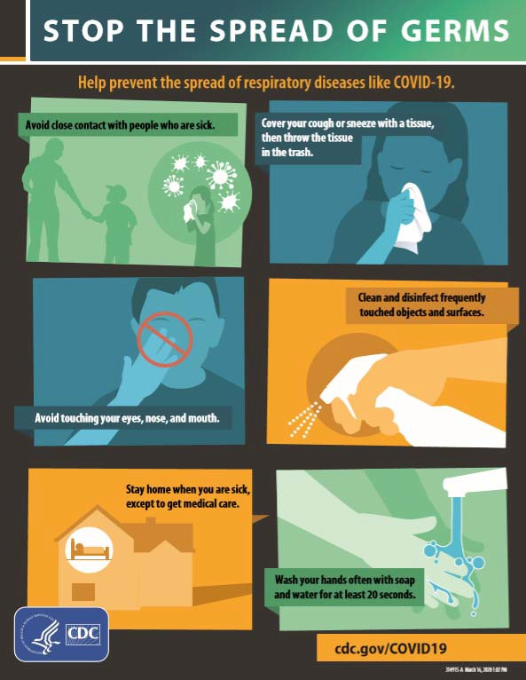
Resources for COVID-19

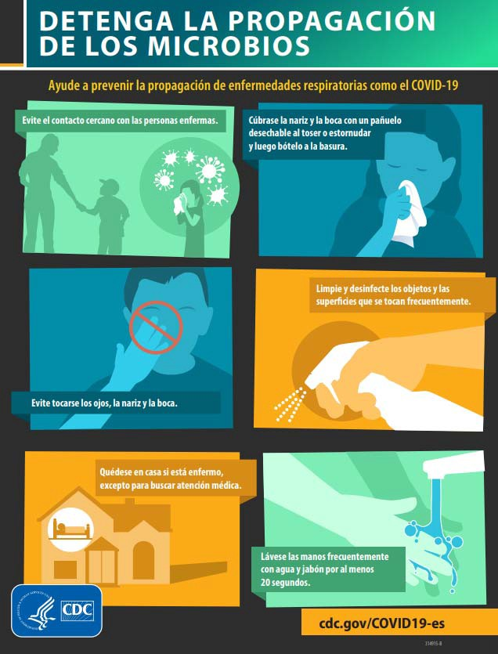

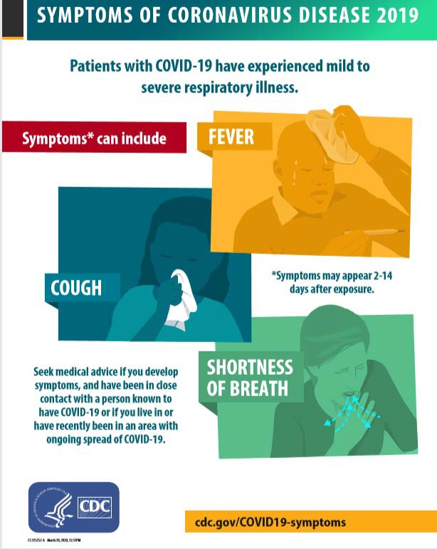
Printable flyers from CDC in English and Spanish https://www.cdc.gov/coronavirus/2019‐ncov/symptoms‐testing/symptoms.html

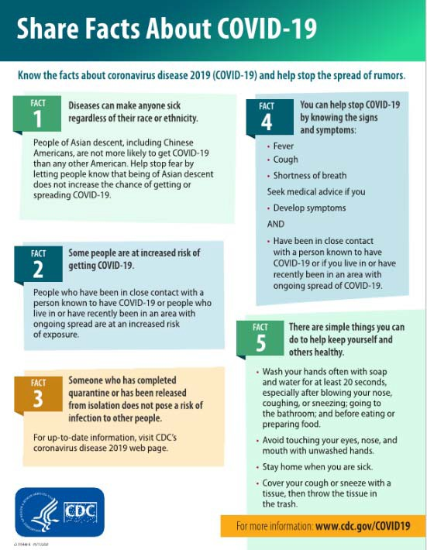

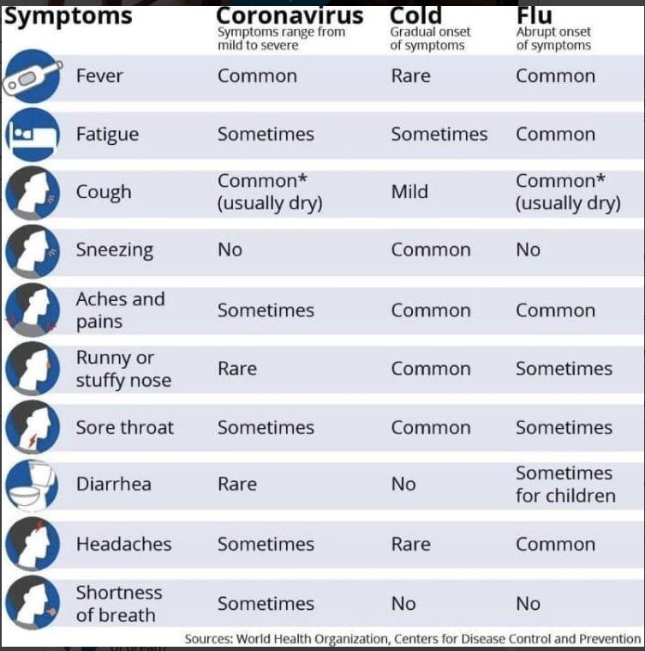

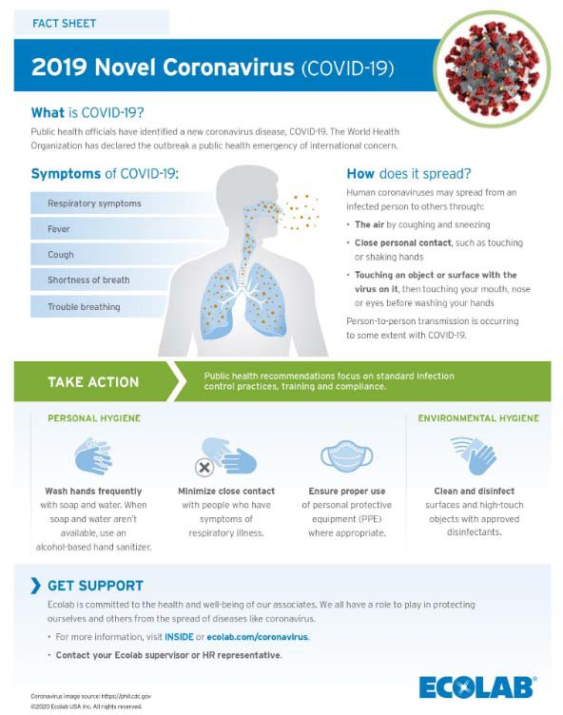

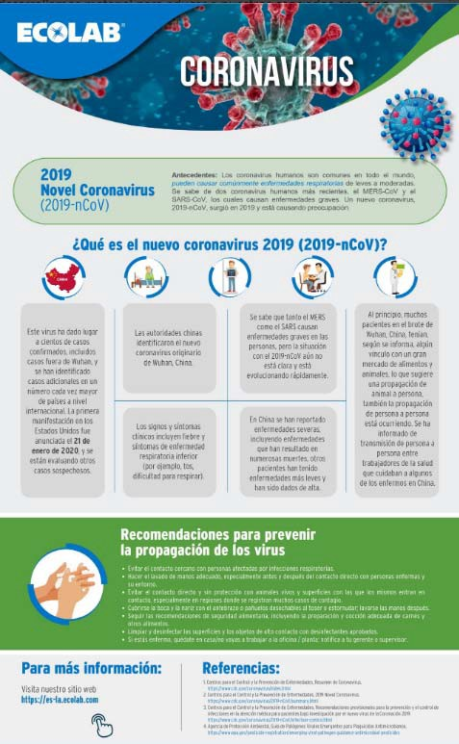

References
CPWR Guidance on COVID 19 https://www.cpwr.com/sites/default/files/CPWR_Guidance_on_COVID.pdf
CDC Coronavirus (COVID‐19) https://www.cdc.gov/coronavirus/2019‐nCoV/index.html COVID 19 OSHA
https://www.osha.gov/SLTC/covid‐19/
WHO Coronavirus https://www.who.int/emergencies/diseases/novel‐coronavirus‐2019
EcoLab www.Ecolab.com/coronavirus
https://es‐la.ecolab.com/pages/coronavirus

