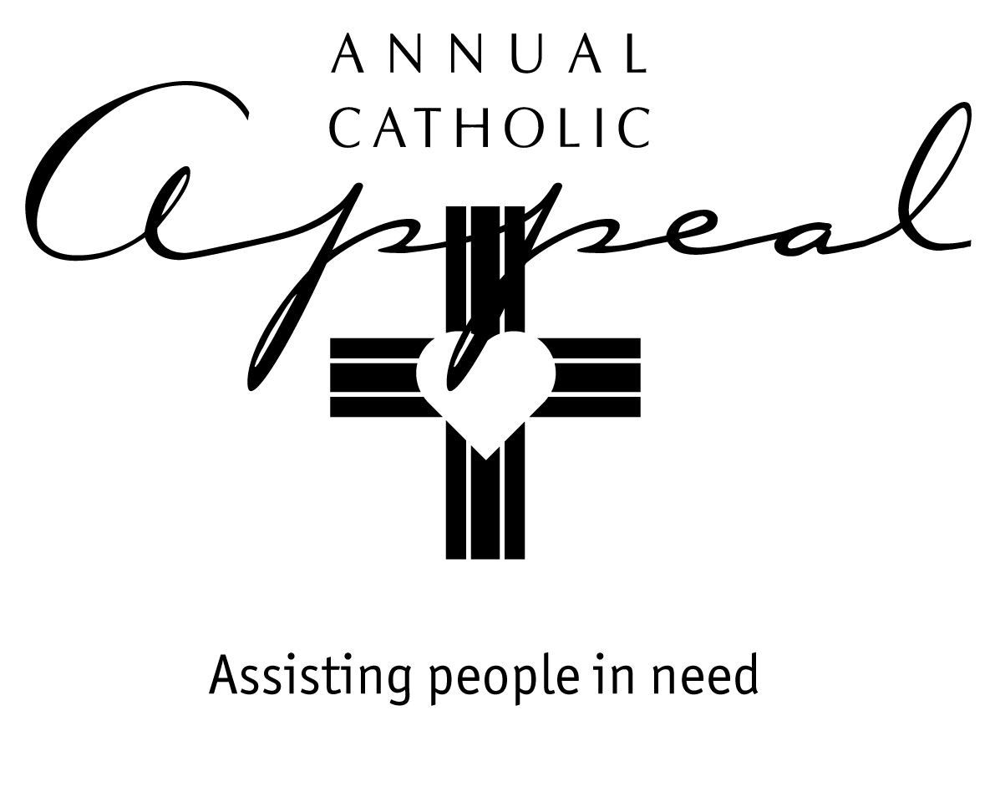

FEBRUARY 8/9 - FEBRUARY 15/16
AWARENESS WEEKENDS

Bulletin and Mass Announcement

Be there for others through the Annual Catholic Appeal

On the weekend of February 22, we will once again have the opportunity to walk with others as Jesus asks us to do. Together as Catholics, the Appeal is a way we can all help in a powerful way. Many of our sisters and brothers in the North State have endured catastrophic natural disasters. Others still struggle on the margins of communities. Let us remember them and that each of our gifts, no matter the amount, really do make a difference in someone’s life. Please prayerfully consider what you can give this year.

Prayer of the Faithful

For the People of God in the Diocese of Sacramento…as we consider all that God has so generously given us, that He will open our hearts as we consider our participation in the Annual Catholic Appeal and for our sisters and brothers we pray…

…Lord, hear our prayer.

(Please modify these announcements and prayers to fit your parish.
Consider adding how your parish will use the 25% share.)

FEBRUARY 22/23 – APPEAL WEEKEND

Bulletin and Mass Announcement

Today we join together through
the Annual Catholic Appeal

We may not all be social workers, yet through the Annual Catholic Appeal, the whole Catholic community leans in to help our Catholic charities…and our own parish…providing support to programs and ministries that help lift our neighbors and friends out of poverty.

The Annual Catholic Appeal is dedicated solely to the social mission of the Church here in Northern California. Last year, 261,000 people were helped through Appeal-funded charitable works. Please be as generous as you can. Every gift makes a profound difference in someone’s life.

Prayer of the Faithful

For all who depend on our generosity through the Annual Catholic Appeal: those who need assistance and all those who work tirelessly in the charitable organizations and parish outreach ministries that serve them…

For our sisters and brothers we pray…

Lord, hear our prayer.

(Please modify these announcements and prayers to fit your parish)

FEBRUARY 29/ MARCH 1 – MARCH 7/8
FOLLOW UP WEEKENDS

Bulletin and Mass Announcement

Thank you for helping our neighbors in need through
the Annual Catholic Appeal

Your gift will make a difference in someone’s life. If you have not yet made a donation, it’s not too late! Envelopes are still available in the church or in the parish office. Please remember…25% of what you give is returned to our parish to assist people in our own community who need help.

Prayer of the Faithful

For all who have given generously to the Annual Catholic Appeal…for those who are still prayerfully considering what they can give…and for all those in need who will benefit from our generosity…

For our sisters and brothers we pray…

Lord, hear our prayer.

(Please modify these announcements and prayers to fit your parish)

